060010715-Wireless Networks

Haptics (Piezoelectric Sensors)

Enrollment No: 201806100110094

**What are Haptic or Piezoelectric Sensors?**

Haptic technology, also known as kinaesthetic communication or 3D touch, refers to any technology that can create an experience of [touch](https://en.wikipedia.org/wiki/Somatosensory_system) by applying [forces](https://en.wikipedia.org/wiki/Force), [vibrations](https://en.wikipedia.org/wiki/Vibration), or motions to the user. Haptic devices may incorporate [tactile sensors](https://en.wikipedia.org/wiki/Tactile_sensor) that measure forces exerted by the user on the interface



**Haptic sensors have been around for a while now and come in various forms. Regardless of the type of haptic technology utilized. Here, we will look at haptic sensors as a whole and how they work.**

**How Haptic Sensors Work**

There are three main types of haptic sensor:

* eccentric rotating mass vibration (ERMV) motors
* linear resonant actuators (LRAs)
* piezo haptics sensors.

Even though there is a general principle for haptic sensors, this article will highlight some of the operational differences between the different types of sensors. Aside from using a combination of force, vibration, and motions, haptic technologies use a force feedback loop to manipulate the movement of the user and go beyond a simple vibration alert. The basic principle of a haptic sensor is the generation of an electric current that drives a response to create a vibration.

**How this happens, how does the different technologies differ?**

However, not all haptic sensors require touch to work. These are known as non-contact haptics and uses technologies such as ultrasound and concentrated air pockets to create an interactive 3D space around the user. The user then interacts with the space around a device without the need to physically touch it.

### **ERMVs**

ERMVs operates in a similar way to a DC motor. ERMVs work by generating a magnetic field from an electric current. The magnetic field drives an object in a circle, using an off-centre bias from the point of rotation. The magnetic force applied to the rotating mass creates an uneven centripetal force that causes the motor to create forward and backward motions, as well as producing lateral vibrations. The intensity of the vibrations produced by ERMVs is often dependent on the current supplied to the device. ERMVs are often the haptic sensor of choice when the driving circuit is simple, a low-cost is required, and the haptic resolution is not the highest priority.

### **LRAs**

LRAs use both magnetic fields and electrical currents to create an oscillating force along a single axis. In comparison to ERMVs, LRAs use an AC voltage instead of DC. These current drives a voice coil that is pressed against a moving mass. The moving mass is attached to a spring, and when the voice coil resonates at the same frequency of the spring, a magnetic field is generated. This magnetic field causes the actuator to vibrate with a force that can be felt by a human. LRAs can be easily adjusted by changing the AC input, but the actuator must always be driven at its resonant frequency. LRAs are best utilized when start/stop timing is critical, the circuit can implement a driver chip, or the vibrational amplitude needs to be adjusted independently.

### **Piezo Haptics**

Piezo haptic sensors work on the principle of the piezo effect to generate a vibration. The piezo effect is a well-known phenomenon that generates an electrical current when a material is mechanically stressed. Under various stresses, such as bending and deformation, a piezo haptic sensor will generate a vibration. Piezo haptic sensors are more precise than inertia-based sensors because they vibrate at a wider range of frequencies and amplitudes. Piezo haptic sensors also vibrate in multiple directions, unlike LRAs and ERMVs which are confined in a single direction. The operation of piezo haptic sensors requires a higher voltage, but the consumption of current is better than, or colloquial to, other haptic sensors. Piezo haptic sensors are often used when a larger space is available to integrate the actuator, the frequency and amplitude need to be adjusted independently, or the circuit can implement a driver chip and produce waveforms.

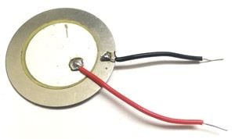

**How Does Piezoelectric sensors work?**

**Piezoelectricity** is the charge created across certain materials when a mechanical stress is applied.

Piezoelectric pressure sensors exploit this effect by measuring the voltage across a piezoelectric element generated by the applied pressure. They are very robust and are used in a wide range of industrial applications.

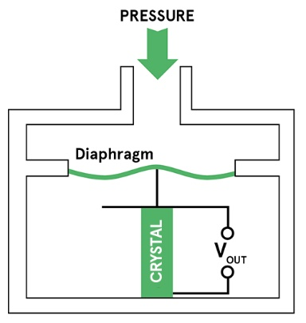

**Working Principle**

When a force is applied to a piezoelectric material, an electric charge is generated across the faces of the crystal. This can be measured as a voltage proportional to the pressure (see diagram to the right).

There is also an inverse piezoelectric effect where applying a voltage to the material will cause it to change shape.

A given static force results in a corresponding charge across the sensor. However, this will leak away over time due to imperfect insulation, the internal sensor resistance, the attached electronics, etc.

As a result, piezoelectric sensors are not normally suitable for measuring static pressure. The output signal will gradually drop to zero, even in the presence of constant pressure. They are, however, sensitive to dynamic changes in pressure across a wide range of frequencies and pressures.

This dynamic sensitivity means they are good at measuring small changes in pressure, even in a very high-pressure environment.

## Function

Unlike piezoresistive and capacitive transducers, piezoelectric sensor elements require no external voltage or current source. They generate an output signal directly from the applied strain.

The output from the piezoelectric element is a charge proportional to pressure. Detecting this requires a charge amplifier to convert the signal to a voltage.

Some piezoelectric pressure sensors include an internal charge amplifier to simplify the electrical interface by providing a voltage output. This requires power to be supplied to the sensor.

An internal amplifier makes the sensor simpler to use. For example, it makes it possible to use long signal cables to connect to the sensor. The amplifier can also include signal-conditioning circuitry to filter the output, adjust for temperature and compensate for the changing sensitivity of the sensing element.

The presence of the electronic components does, however, limit the operating temperature to not much more than 120ºC.

For higher temperature environments, a charge-mode sensor can be used. This provides the generated charge directly as the output signal. It therefore requires an external charge amplifier to convert this to a voltage.

## Design

Piezoelectric pressure sensors are often constructed in a threaded tube (as shown in the diagram below) to make it easy to mount them in equipment where pressure is to be monitored. Care is needed when installing these because over-tightening can affect the output sensitivity.

In some of the typical applications of piezoelectric sensors, they may be exposed to thermal shock (a sudden change in temperature) caused by either radiant heat or the flow of hot gases or liquids past the sensor.

This can cause changes to the output due to heating of the crystal, the diaphragm or the casing of the sensor. Note that this is not the same as the static temperature sensitivity of the sensor.

The effects of thermal shock can be minimised by the design of the enclosure and mounting the sensor to provide isolation.

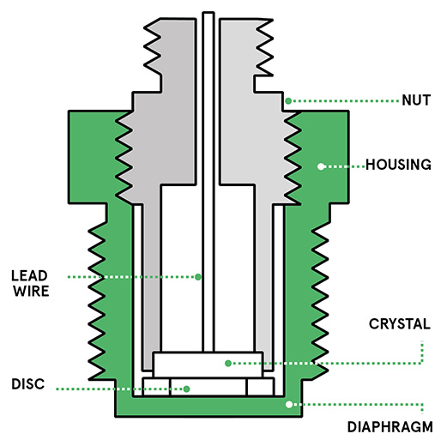

## Advantages and disadvantages

One of the main advantages of piezoelectric pressure sensors is their ruggedness. This makes them suitable for use in a variety of harsh environments.

Apart from the associated electronics, piezoelectric sensors can be used at high temperatures. Some materials will work at up to 1,000ºC. The sensitivity may change with temperature but this can be minimised by appropriate choice of materials.

The output signal is generated by the piezoelectric element itself, so they are inherently low-power devices.

The sensing element itself is insensitive to electromagnetic interference and radiation. The charge amplifier and other electronics need to be carefully designed and positioned as close as possible to the sensor to reduce noise and other signal errors.

Piezoelectric sensors can be easily made using inexpensive materials (for example quartz or tourmaline), so they can provide a low-cost solution for industrial pressure measurement.

## Applications

The robustness, high frequency and rapid response time of piezoelectric pressure sensors mean they can be used in a wide range of industrial and aerospace applications where they’ll be exposed to high temperatures and pressures.

They are often used for measuring dynamic pressure, for example in turbulence, blast, and engine combustion. These all require fast response, ruggedness and a wide range of operation.

Their sensitivity and low power consumption also make them useful for some medical applications. For example, a thin-film plastic sensor can be attached to the skin and used for real-time monitoring of the arterial pulse.

### Vibration

The majority of electronics offering haptic feedback use vibrations, and most use a type of [eccentric rotating mass](https://en.wikipedia.org/wiki/Eccentric_rotating_mass_(ERM)_motor) (ERM) actuator, consisting of an unbalanced weight attached to a motor shaft. As the shaft rotates, the spinning of this irregular mass causes the actuator and the attached device to shake.

### Force feedback

Force feedback devices use motors to manipulate the movement of an item held by the user.

### Mobile devices

Tactile haptic feedback is common in [cellular devices](https://en.wikipedia.org/wiki/Mobile_phone). In most cases, this takes the form of vibration response to touch. [Alpine Electronics](https://en.wikipedia.org/wiki/Alpine_Electronics) uses a haptic feedback technology named PulseTouch on many of their touch-screen car navigation and stereo units. The [Nexus One](https://en.wikipedia.org/wiki/Nexus_One) features haptic feedback, according to their specifications. [Samsung](https://en.wikipedia.org/wiki/Samsung_Electronics) first launched a phone with haptics in 2007.

[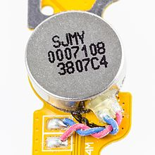](https://en.wikipedia.org/wiki/File:LG_P710_Optimus_L7_II_-_Vibramotor_SJMY0007108-7058.jpg)

Vibramotor of LG Optimus L7 II

Apple's Haptic Touch technology is similar to 3D Touch but it doesn't rely on pressure. Instead, Haptic Touch kicks in when a user long-presses the screen, offering a small vibration as acknowledgement following the press; haptic feedback, hence the Haptic Touch name.

### Robotics

Haptic feedback is essential to perform complex tasks via [telepresence](https://en.wikipedia.org/wiki/Telepresence). The [Shadow Hand](https://en.wikipedia.org/wiki/Shadow_Hand), an advanced robotic hand, has a total of 129 touch sensors embedded in every joint and finger pad that relay information to the operator. This allows tasks such as typing to be performed from a distance. An early prototype can be seen in [NASA](https://en.wikipedia.org/wiki/NASA)'s collection of humanoid robots, or [robonauts](https://en.wikipedia.org/wiki/Robonaut).

### Sensory substitution

In December 2015 David Eagleman demonstrated a wearable vest that "translates" speech and other audio signals into series of vibrations,[[59]](https://en.wikipedia.org/wiki/Haptic_technology#cite_note-59) this allowed hear-impaired people to "feel" sounds on their body, it has since been made commercially as a wristband.